For those of us who still use glow engines to power our RC vehicles here an easy, inexpensive, and powerful glow igniter solution. I fly glow powered planes and have been using a form of this igniter for years. I recently had the case on the original box break and had the choice to replace the box or build a new one. Given the age of the batteries and other considerations, I decided to just build a new one.

The first step is to acquire the parts. Because time was not an issue and the cost is much less, all of the parts were ordered on Ebay from sources in China. Here is the parts list and cost (all costs are with free shipping):
Plastic Electronic Case Project Enclosure 115x90x55 | 3.06
6A 2-Pin ON/OFF Rocker Toggle SPST Switches (10pcs) | 1.23
DC-DC Buck Step Down Conv, 4-38v In, 1.25-36v Out | 1.56
DC 100V 10A Voltmeter Ammeter Blue + Red LED | 2.53
Battery 18650 3.7v 9800mAh Li-ion Rechargeable (2pcs) | 2.52
Plastic Battery Holder, 2 Cell, 18650 Battery | .99
2S BMS PCB Protection Board for 2 Cell 18650 Li-Po Li-ion | 1.42
Schottky Diode 40V 10A (10pcs) | 6.00
Deans Ultra or XT60 Female Connector (personal choice) | In house stock
Dubro Extra Long Kwik-Klip II Glow Plug Clip (Ebay, US, $11.68) | In house stock

As you can see it’s cheap!!! And powerful, 7.4V, 10A!! When stepped down, a 4A, 1.5v glow plug will only draw +- 1.5A at the battery. The BMS board protects the battery, circuit components, and your house, against overcharge, short/high current load, and low cell voltage. The entire circuit is rated at 5A constant, 8A burst. The one I have been using for years is the same circuitry minus the BMS board and uses 3000mah Li-Ion batteries. High current glow plugs, such as O.S. Type “F”, will draw about 4.5A maximum. At the battery circuit it’s less than 1.5A with a semi-shorted plug.
I had considered adding a timer relay board in the circuit to automatically shut it off after a minute or so. But at idle the entire box only draws about 200ma and with a 10A battery (+- 40 to 50 hrs.) it didn’t seem to be worth it. Plus if either of the cells gets down to +- 2.7V the BMS board will shut the circuit off.

Here’s the circuit diagram:
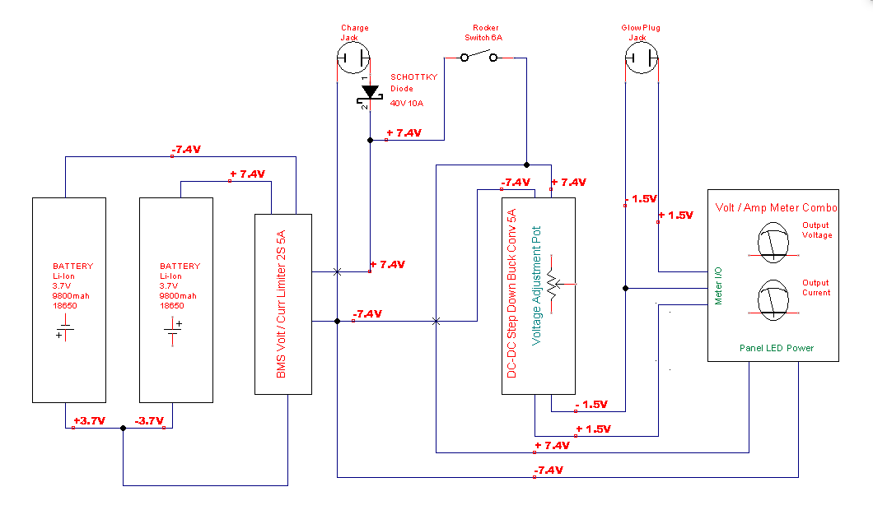

Construction starts by locating all of the components in the project box. Once you’re satisfied with the layout cut the opening for the switch, meter, charge jack, and output jack. As I stated in the parts list, the selection of jacks is a personal choice, I use Dean’s T Plugs on everything as I did on the charge jack here. I used a XT60 connector on the glow plug jack so that charge and output don’t get confused.

Next, solder the BMS board to the batteries. The board draws 0 current when inert so it is placed before the switch. This allows charging to occur with the unit turned off. The board looks like this:
