I75 Exit 288 Hwy 113 – Turn right onto Hwy 113
Continue thru Cartersville – Ga 61 joins Hwy 113 in town
Continue out of town. Turn left when GA 61 and Hwy 113 split
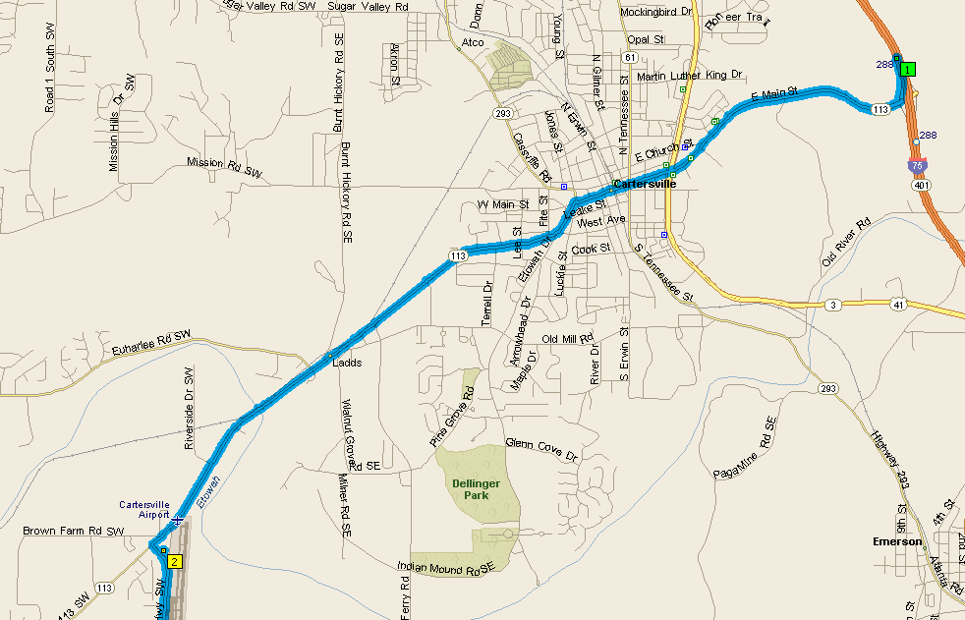

Continue on Ga 61 for about 15 miles. In “downtown” Dallas 61 makes a left turn.
Continue 1 mile. Ga 61 makes a right turn. Stay on Ga 61 about 5 miles
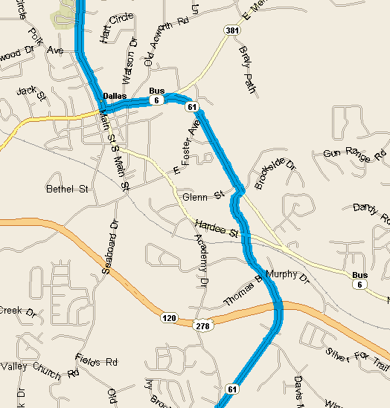
After US 278, about 3 miles, go thru the stop light (@ McDonald’s) for 1 mile.
Turn left on Dallas-Nebo Rd. Continue .3 Mile, turn right onto Gainsborough Dr., Immediate left onto Shockley Way.
Third house on left
